
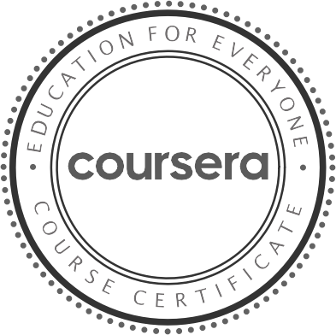


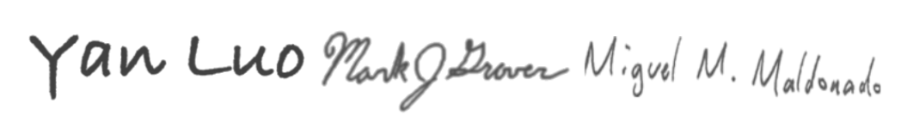

Nov 12 , 2025

SUKMA ARIF WIBOWO SUKMA

has successfully completed

Supervised Machine Learning: Classification

an online non-credit course authorized by IBM and offered through Coursera

Yan Luo Mark Grover
Miguel Maldonado

V erify at: https://coursera.org /verif y /529O0TB16Z34
C ou rsera h as con firmed th e id en tity of th is in d iv id u al an d
th eir p articip ation in th e cou rse.

